## **About Us**

**AAAAA** stands at the forefront as a leading provider of Geographic Information Systems (GIS) services and solutions. Our core focus revolves around harnessing spatial data to empower organizations in making well-informed decisions, streamlining operations, and tackling intricate challenges. Backed by a dedicated team of GIS professionals and cutting-edge technology, we deliver comprehensive services meticulously tailored to meet the distinctive requirements of clients spanning diverse industries.

Our commitment to excellence is a cornerstone at **AAAAA**, permeating every facet of our work. We enthusiastically embrace emerging technologies and consistently refine our processes to furnish clients with the most sophisticated solutions available. Our professional ethos ensures the establishment of robust, enduring relationships with clients, characterized by mutual trust and respect.

We specialize in various domains of ESRI products, including GIS map creation, raster management, DTM/DSM services, 3D city modeling, and Civil 3D products. Our proficiency extends to cadastral mapping, utility mapping, transportation mapping, as well as hydrographic/flood mapping. At **AAAAA**, we pride ourselves on delivering expertise that meets the diverse needs of our clients with precision and effectiveness

## **Our Range of Services Includes:**

* Digital Photogrammetry
* UAV Survey and 3D Mapping
* Ortho & True Ortho Photo
* LiDAR
* 3D City Modeling
* MLS (Mobile LiDAR Survey) and TLS (Terrestrial LiDAR Survey)
* Spatial Analysis
* Civil 3D & DOT Products
* PLSS Products

### **Digital Photogrammetry**

Unlock the power of precise spatial insights with our cutting-edge Digital Photogrammetry services. As a leading player in Geospatial Technology, we specialize in extracting three-dimensional information about objects and landscapes from two-dimensional images captured by cameras, drones, or satellites. Our Digital Photogrammetry solutions amalgamate principles from photography, computer vision, and geometric modeling, delivering accurate and intricate representations of Earth's surface and constructed environments.

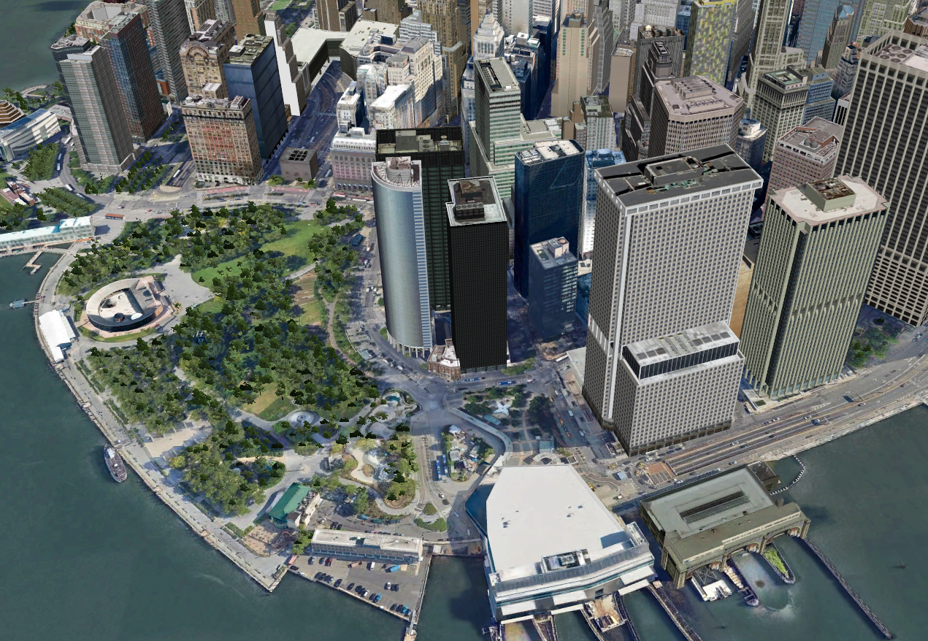

#### Our Expertise:

##### Topographic Mapping:

Develop precise topographic maps for engineering, land management, and infrastructure planning. Our Digital Photogrammetry ensures accuracy in every detail, supporting your projects with reliable spatial data.

##### 3D City Modeling:

Create high-resolution 3D City models, captivating landscapes, and preserve cultural heritage sites for visualization, simulation, and virtual reality applications. Immerse yourself in detailed and realistic representations of urban environments.

##### Mining and Construction Analysis:

Support precise measurement and analysis of stockpiles, terrain profiles, and land surface changes in mining and construction. Our Digital Photogrammetry aids in optimizing operations and enhancing environmental monitoring efforts.

##### Land Use and Cover Classification:

Facilitate land use and land cover classification, change detection, and spatial analysis for urban planning, agriculture, forestry, and environmental conservation. Make informed decisions based on detailed and up-to-date information.

##### Environmental Monitoring and Resource Management:

Contribute to surveying for environmental monitoring and resource management. Provide critical data for assessing habitat quality, monitoring wildlife populations, detecting changes in land use and cover, and mapping natural hazards.

##### Key Insights:

Digital Photogrammetry assumes a pivotal role in capturing, analyzing, and visualizing spatial information, facilitating precise mapping, modeling, and monitoring of Earth's surface and built environments. As technology continues to evolve, our Digital Photogrammetry services are poised to advance further, presenting new opportunities for innovation and application across diverse industries.

##### Why Choose Us:

**Expert Team:** Our skilled professionals bring expertise in the latest technologies and methodologies in Digital Photogrammetry.

**Tailored Solutions:** We understand the unique needs of our clients and provide customized services to meet specific project requirements.

**Cutting-edge Technology:** Stay at the forefront with our use of cutting-edge technology, ensuring the highest quality and accuracy in every project.

##### Experience the Future of Spatial Insights:

Explore the endless possibilities of Digital Photogrammetry with our services. Contact us today to elevate your mapping, modeling, and monitoring needs. Uncover the world of precision and innovation in spatial data analysis with us!

### **UAV Survey and 3D Mapping Services**

At **AAAAA**, we bring innovation to the forefront with our cutting-edge UAV Survey and 3D Mapping solutions. Unmanned Aerial Vehicles (UAVs) have revolutionized surveying and mapping, enabling us to capture intricate details and create stunning 3D visualizations with unparalleled precision.

#### Our Services:

##### UAV Survey:

Our UAV survey services redefine data collection. Utilizing state-of-the-art drones equipped with advanced sensors, we capture high-resolution imagery and gather geospatial data efficiently. From topographic mapping to infrastructure inspection, our UAV surveys provide accurate and up-to-date information for diverse applications.

##### 3D Mapping:

Immerse yourself in the world of three-dimensional mapping with our expertise in creating realistic and detailed models. We transform captured data into vibrant 3D maps and models, offering valuable insights for urban planning, architecture, land development, and more. Our 3D mapping services bring your projects to life with depth and precision.

##### Applications:

**Construction and Engineering:** Monitor construction progress, assess site conditions, and enhance project planning.

**Environmental Monitoring:** Analyze terrain, vegetation, and changes over time for informed conservation efforts.

**Infrastructure Planning:** Visualize landscapes in 3D to optimize infrastructure development and design.

**Urban Development:** Plan and model urban spaces with accuracy, aiding in zoning and development decisions.

**Precision Agriculture:** Optimize farming practices with detailed 3D maps for crop health assessment and resource management.

##### Why Choose Us:

**Advanced Technology:** We employ the latest UAV technology and 3D mapping software to ensure the highest quality results.

**Expert Team:** Our team of skilled professionals combines technical expertise with a passion for delivering outstanding results.

**Tailored Solutions:** Customized services to meet the unique requirements of your projects, ensuring optimal outcomes.

##### Get Ready for Elevated Perspectives:

Transform your projects with the power of UAV Survey and 3D Mapping. Contact **AAAAA** today to explore how our services can bring a new dimension to your mapping and surveying needs. Elevate your perspective, enhance your insights, and redefine your project outcomes with us!

### **Ortho & True Ortho Photo Services**

Ortho and True Ortho Photos are advanced imaging solutions that provide accurate and detailed representations of landscapes, infrastructure, and built environments. These services play a crucial role in various industries, offering unparalleled precision in mapping, analysis, and visualization.

#### Our Services:

##### Ortho Photos:

Our Ortho Photo services involve the production of high-resolution, georeferenced aerial images with minimal distortion. These images are meticulously corrected for terrain relief, camera tilt, and lens distortion, ensuring an accurate representation of the Earth's surface.

##### True Ortho Photos:

True Ortho Photos take precision to the next level by combining high-resolution imagery with digital surface models. This results in orthorectified images that eliminate building lean and provide a true-to-scale representation of features on the ground. True Ortho Photos are ideal for applications requiring the utmost accuracy.

##### Applications:

**Urban Planning**: Accurate mapping for infrastructure development and city planning.

**Engineering**: Detailed topographic maps for engineering projects and land management.

**Agriculture**: Precision agriculture, crop monitoring, and land-use planning.

**Environmental Monitoring**: Assessing land surface changes, habitat quality, and natural resource management.

**Infrastructure Planning**: Visualizing landscapes and built environments for better decision-making.

##### Why Choose Us:

**Accuracy**: Our Ortho & True Ortho Photos are produced with a focus on precision, ensuring reliable data for your projects.

**Expertise**: Backed by a team of skilled professionals well-versed in geospatial technology and imaging solutions.

**Custom Solutions**: Tailored services to meet the specific needs of your industry and project requirements.

##### Get in Touch:

Explore the power of Ortho & True Ortho Photos for your projects. Contact us today to discuss how our services can elevate your mapping, modeling, and analysis needs. Experience the difference accuracy makes with our advanced imaging solutions!

### **LiDAR Solutions**

Embark on a journey of precision and depth with our state-of-the-art LiDAR services. LiDAR, or Light Detection and Ranging, is at the heart of our Geospatial Technology offerings, utilizing laser pulses to measure distances and deliver unparalleled insights into Earth's surface. Our LiDAR solutions cover a spectrum of applications, providing accurate and detailed data for various industries.

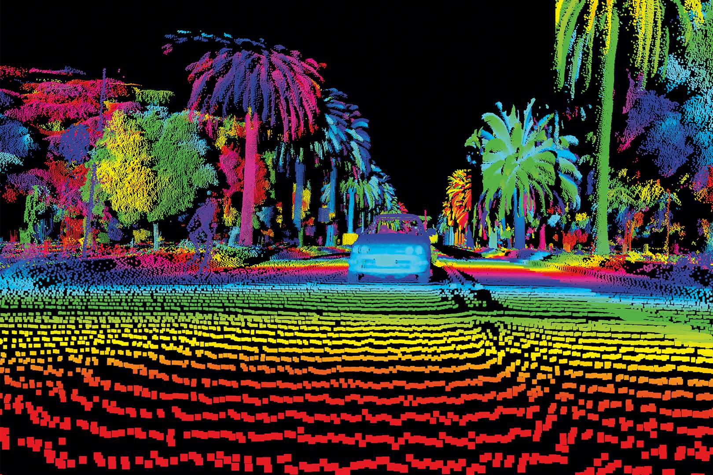

#### **Our LiDAR Services:**

##### Topographic Mapping:

Capture the landscape in exquisite detail with LiDAR, generating high-resolution digital elevation models (DEMs) and terrain models. Ideal for topographic mapping, land surveying, and engineering applications.

##### Forestry Management:

Gain detailed information about forest structure, canopy height, biomass, and vegetation density. Our LiDAR services support forestry management, biodiversity assessment, and habitat mapping.

##### Urban Environment Mapping:

Achieve precise mapping of urban environments, including buildings, roads, utilities, and infrastructure assets. LiDAR supports urban planning, 3D city modeling, and asset management initiatives.

##### Natural Hazard Assessment:

Assess and monitor natural hazards such as landslides, floods, and coastal erosion. LiDAR mapping of terrain morphology identifies hazardous areas and analyzes terrain stability.

##### Archaeology and Cultural Heritage:

Assist archaeologists and cultural heritage experts in identifying and mapping archaeological sites, cultural landscapes, and historical structures with high precision and detail.

##### Transportation Engineering:

Support transportation engineering projects by providing accurate terrain models, assessing road conditions, and planning transportation infrastructure such as highways, railways, and airports.

##### Key Learnings:

LiDAR emerges as a versatile remote sensing technology, offering precise and detailed information about the Earth's surface and vegetation structure. From topographic mapping and forestry management to urban planning and natural hazard assessment, LiDAR finds diverse applications across various industries and disciplines. Our commitment to excellence ensures that you receive the most accurate and reliable LiDAR data for your projects.

##### Why Choose Us:

**Cutting-edge Technology:** We leverage the latest LiDAR technology to ensure the highest quality and accuracy in our services.

**Expert Team:** Our skilled professionals bring extensive expertise in LiDAR applications, ensuring the success of your projects.

**Customized Solutions:** Tailored LiDAR services to meet the unique requirements of your projects, delivering precise and actionable insights.

##### Experience Precision in LiDAR Technology:

Transform your projects with the depth and accuracy of LiDAR. Contact us today to explore how our LiDAR solutions can elevate your mapping, modeling, and analysis needs. Step into a new era of geospatial data with our advanced LiDAR services!

### **3D City Modeling**

Step into a world where urban planning and visualization reach new heights! At [Your Company Name], we are thrilled to introduce you to our state-of-the-art 3D City Modeling services. Dive into a realm where digital representations of urban environments come to life, providing unparalleled insights and perspectives.

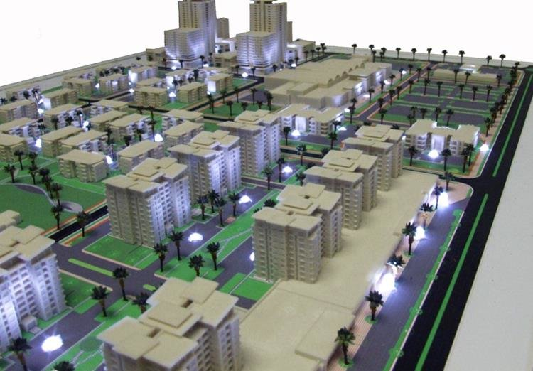

#### Our 3D City Modeling Services:

##### Urban Planning and Design:

Envision the future with our 3D city models, aiding urban planners and architects in visualizing proposed development projects, assessing the impact of new structures, and designing sustainable urban environments.

##### Real Estate Development:

Elevate your real estate ventures by leveraging our 3D city models. From evaluating properties to conducting site assessments and marketing real estate assets, our immersive visualizations bring properties to life for buyers and investors.

##### Disaster Preparedness and Response:

Rely on our 3D city models for effective disaster preparedness, response, and recovery efforts. Support risk assessment, evacuation planning, and damage assessment by gaining detailed information about the built environment and infrastructure networks.

##### Tourism Experiences:

Enhance tourism experiences with virtual tours, interactive maps, and immersive journeys through historical sites, landmarks, and cultural heritage. Our 3D city models preserve and promote cultural heritage, offering educational and engaging initiatives.

##### Transportation Planning:

Facilitate transportation planning, traffic management, and infrastructure development by visualizing road networks, public transportation systems, and traffic flow patterns. Analyze congestion, optimize routes, and design efficient transportation infrastructure.

##### Environmental Impact Assessment:

Assess environmental impacts, analyze green spaces, and evaluate energy efficiency measures within urban areas. Our 3D city models support sustainable urban development, green infrastructure planning, and climate change adaptation initiatives.

#### Why Choose Us:

**Cutting-edge Technology:** We utilize the latest advancements in 3D modeling technology to deliver realistic and detailed city representations.

**Customized Solutions:** Tailored services to meet the specific needs of your projects, ensuring precision and relevance.

**Interdisciplinary Expertise:** Our team brings together diverse skills in geospatial data acquisition, processing, and visualization to create comprehensive 3D city models.

##### Experience the Future of Urban Visualization:

Embark on a journey where urban planning and visualization meet innovation. Contact us today to explore how our 3D City Modeling services can transform your projects, providing a new dimension to your planning, design, and management needs. Welcome to the forefront of urban modeling with [Your Company Name]!

### **Mobile LiDAR Survey (MLS):**

### We bring innovation to the forefront of surveying with our state-of-the-art Mobile LiDAR Survey (MLS) services. Revolutionizing the data collection landscape, Mobile LiDAR Survey involves mounting LiDAR sensors on mobile platforms, providing highly accurate and detailed 3D point cloud data for various applications. Explore the efficiency, speed, and precision that define our MLS services.

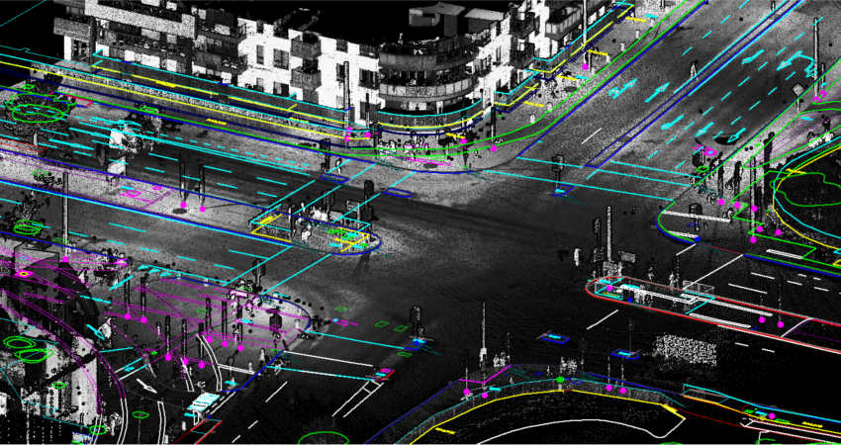

#### Our MLS Services:

##### Transportation Asset Management:

### Supporting transportation agencies, our Mobile LiDAR Survey ensures accurate 3D data for asset management, road maintenance, and infrastructure planning. From pavement analysis to bridge clearance assessments, we deliver actionable insights.

##### Urban Planning and Development:

### In urban planning, our surveys create detailed 3D models of cityscapes, building footprints, and streetscapes. [Your Company Name] supports land use planning, zoning analysis, and visualization for proposed development projects.

##### Utility Infrastructure Mapping:

### Mapping utility infrastructure such as power lines, pipelines, and telecommunications networks, our MLS services assist utilities companies in asset management, vegetation encroachment analysis, and emergency response planning.

##### Environmental Monitoring and Resource Management:

### Employed for environmental monitoring, our surveys provide detailed topographic data for floodplain mapping, coastal erosion studies, vegetation analysis, and habitat mapping. Contribute to sustainable resource management with accurate insights.

##### Emergency Response and Disaster Management:

### In disaster management, [Your Company Name]'s Mobile LiDAR Surveys support rapid damage assessment, evacuation planning, and infrastructure restoration. Our services play a crucial role in post-disaster recovery efforts.

##### Why Choose [Your Company Name] for MLS:

### **Rapid and Efficient Data Collection:** Our MLS services ensure swift data collection over large areas with minimal disruption to traffic flow.

### **Interdisciplinary Expertise:** Benefit from a team that combines expertise in surveying, geospatial technology, and mobile LiDAR applications to deliver comprehensive solutions.

### **Versatility:** Our Mobile LiDAR Surveys cover a diverse range of applications, providing valuable insights for various industries.

##### Experience the Future of Surveying:

### Transform your surveying experience with the speed, accuracy, and versatility of our Mobile LiDAR Survey services. Contact us today to explore how [Your Company Name] can elevate your asset management, planning, and environmental monitoring needs. Welcome to the future of surveying!

### **Civil 3D Products**

Welcome to the forefront of civil engineering design and documentation with AutoCAD Civil 3D, a powerful software developed by Autodesk. At [Your Company Name], we harness the capabilities of Civil 3D to transform the way civil engineers, drafters, and designers approach projects related to roads, highways, land development, and more.

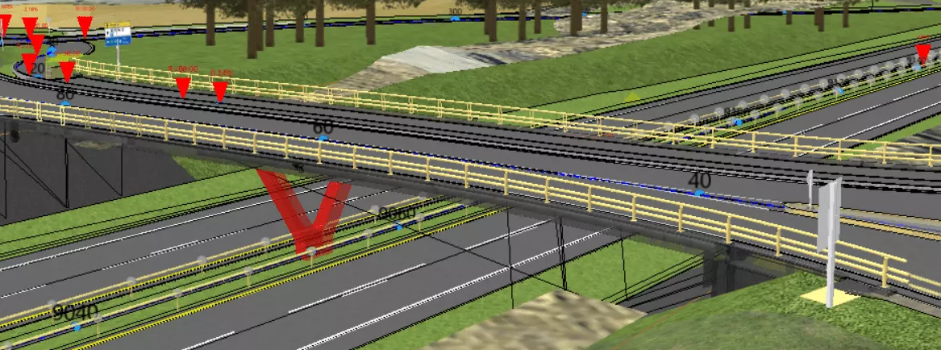

#### **Our Use of Civil 3D Products:**

##### Road and Highway Design:

Utilize Civil 3D for designing roads and highways. Engineers can create alignments, profiles, and corridors to model road geometry, cross-sections, intersections, and grading with precision.

##### Land Development Projects:

In land development projects, Civil 3D is instrumental in designing site grading, earthworks, and drainage systems. It aids in creating surfaces, parcels, and optimizing the layout of buildings and infrastructure.

##### Integration with Surveying Tools:

Civil 3D seamlessly integrates with surveying tools, allowing for the import and use of survey data in the design process. This ensures accurate representation of existing conditions for reliable project bases.

##### Geospatial Capabilities:

Leverage the geospatial capabilities of Civil 3D to incorporate GIS data, analyze geographic information, and integrate it into the design. This is particularly useful for understanding the broader context of a project.

##### Construction Documentation:

Generate construction documentation effortlessly with Civil 3D. The software streamlines the process of creating detailed drawings, including plan sheets, profiles, and cross-sections, essential for construction purposes.

##### Learnings:

AutoCAD Civil 3D is more than just software; it's a versatile tool that finds practical use in road and highway design, land development, hydraulic and hydrologic analysis, pipeline and utility design, surveying, geospatial analysis, earthwork calculations, and construction documentation. Its ability to handle complex 3D modeling, integrate with survey data, and support interdisciplinary collaboration makes it an invaluable asset for civil engineering projects of varying scales and complexities.

##### Why Choose [Your Company Name] for Civil 3D Products:

**In-Depth Expertise:** Our team possesses in-depth expertise in utilizing Civil 3D products for diverse civil engineering projects.

**Efficient Design:** We leverage the functionalities of Civil 3D to optimize the design process, ensuring efficiency and accuracy in every project.

**Interdisciplinary Collaboration:** AAAAA understands the importance of interdisciplinary collaboration and uses Civil 3D as a tool to enhance communication and integration across project teams.

##### Experience the Future of Civil Engineering Design:

Explore the possibilities of civil engineering design with the power of AutoCAD Civil 3D. Contact us today to discover how [Your Company Name] can revolutionize your projects, providing innovative and efficient solutions for your civil engineering needs. Welcome to a new era of design excellence!